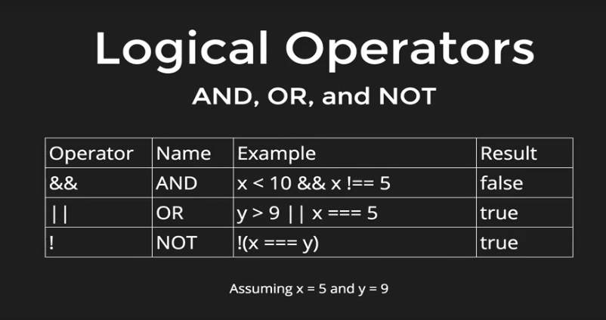

* Example:
  + var x = 10;  
    var y = ‘a’;  
      
    y == ‘b’ || x >= 10;  
    - True
  + var x = 3;  
    var y = 8;  
      
    !(x == “3” || x == = y) && !(y != 8 && x <= y);  
    - False

Truthy and Falsy

* Every value in javascript it is either truthy or falsey
* One way to check
  + Example:
    - !”Hello”